Protein needs are different for everyone, so what determines how much we need to eat? Protein requirements depend primarily on a person’s lean mass and rate of protein turnover. Protein turnover increases with illness, inflammation, strength training, growth, and aging.

To Estimate Protein Needs:
- Calculate the person’s weight in kilograms (kg = lb / 2.2)
- Multiply the weight in kg by the recommended RDA

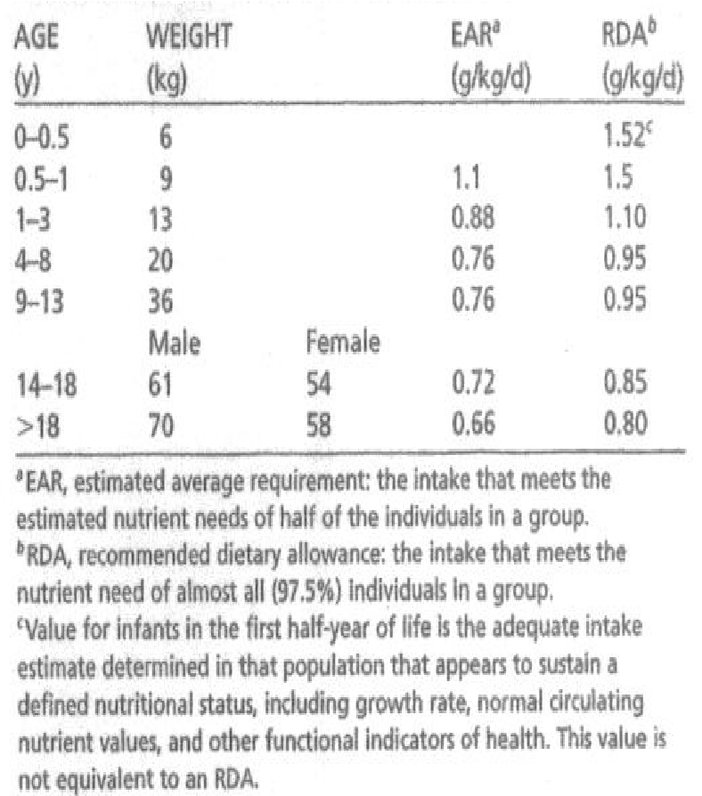
RDA for Health
y

Populations

RDA for Other Populations

Mild stress 0.8-1 g/kg
Inflammation/Infection 1-1.2 g/kg
Moderate Stress (Chronic Illness) 1.2-1.5 g/kg
Sepsis 1.5-2 g/kg
Severe Burns 2-2.5 g/kg

Average strength training individual 1-1.2 g/kg
Elderly 1-1.2 g/kg
Pregnancy 1-1.2 g/kg

Athletes:
Endurance athletes 1.2-1.4g/kg
Strength training athletes 1.7
Body builders 2.1-2.8g/kg
Calculate the protein needs for each individual below. Then create a simple estimated meal plan to ensure they meet their protein needs.

- A 22-year-old male of average health, weighing 160lb

72.5748kg*0.85 = 61.68858

- An adult female vegetarian weighing 130lb

58.967kg*1.2 = 70.7604

- An adult female age 65, weighing 150lb, strength training 2-3 days per week.

68.0389kg*0.8 = 54.43112

- A 280lb body builder

127.006kg*2.8 = 355.6168

- A 30-year-old male with Lupus (autoimmune disease) weighing 160lb
72.5748kg*1.3 = 94.347245

- A Diabetic female 5ft 6inches tall, weighing 200lb (Ideal Body Weight = 130lb)
  - For this person, they are >130%IBW
  - We must first adjust for obesity
  - Adjusted Weight for Obesity
= (Actual Weight – Ideal Body Weight) x 0.2 + Ideal Body Weight

(200-130)*0.2 + 130 = 144lb
65.3173kg*1.6 = 104.50768

- A 6ft tall male, weighing 125lb with an Ideal Body Weight of 178lb
  - This person is <75%IBW so they need to gain weight
  - First, calculate their calorie needs at 30-32kcalories/kg
  - Current protein recommendations = 10-35% of total calories
  - Protein is 4 kcals/g
  - How many grams of protein should he have? (Report the range) 0.8 grams to 1.2 grams
  - What is the RDA in g/kg/day? 1.3 g/kg/day
  - Is this enough protein? Yes the protein is enough

